ResoScan
Non-Invasive Biomechanical Diagnostics via Resonant Modal Spectroscopy
Mentor Briefing Document — Unisys Innovation Program 2026
Ramaiah Institute of Technology, Bengaluru

Team & Mentor Details

Student Team
Name | Department | Contact
Yashas N | Artificial Intelligence & Data Science | yashraaj2005@gmail.com
Jeeth Bhavesh Kataria | Artificial Intelligence & Data Science | jeethkataria9798@icloud.com
Naveen Gopalakrishna Patil | CSE (AI & Machine Learning) | naveengpatil26@gmail.com
Aditya Sarap | Electronics & Telecommunication | adityasarapworld@gmail.com

Project Guide
Dr. Sowmya B. J., Associate Professor, Dept. of Artificial Intelligence & Data Science, M S Ramaiah Institute of Technology | sowmyabj@msrit.edu

Executive Summary
ResoScan is a low-cost, portable, handheld medical device that performs non-invasive biomechanical tissue diagnostics. It digitizes the centuries-old clinical technique of percussion and palpation, turning a physician's subjective tap-and-feel into quantifiable, objective data.
Target Cost: Under ₹8,000 BOM | Applications: Orthopedics, Pulmonology, Urology | Technology: Resonant Modal Spectroscopy + ML

Problem Statement & Motivation

Why Does This Problem Exist?
Modern medical diagnostics relies on imaging modalities like X-ray, CT, MRI, and Ultrasound. While powerful, these share a critical limitation: they reveal structure, not function. For example:
- A healed fracture may appear bridged on X-ray weeks before it can safely bear weight.
- A mass detected on ultrasound cannot be characterized without additional invasive testing.
- These technologies require expensive infrastructure, trained radiologists, and often expose patients to ionizing radiation.

The Five Core Problems

Problem | Description
Structure-Function Gap | Radiographic healing lags behind mechanical strength recovery, causing premature loading or unnecessary immobilization.
Subjectivity of Clinical Exam | Percussion and palpation depend on clinician skill; reported sensitivities as low as 56% for certain conditions.
Cost Inaccessibility | FibroScan costs ₹16-37 Lakhs, MyotonPRO ₹5-6 Lakhs, Osstell ₹3-4 Lakhs — far beyond most clinics.
Invasive Monitoring | Bladder compliance, fracture stability, and lung pathology often require invasive or radiation-heavy procedures.
The 'Missing Middle' | No intermediate functional diagnostic device exists between ₹1,000 clinical tools and ₹15+ Lakh imaging systems.

Proposed Solution: How ResoScan Works
ResoScan employs Resonant Modal Spectroscopy (RMS) — a technique that delivers controlled mechanical impulses to tissue and analyzes the vibrational response to characterize tissue type and health state.

Core Operating Principle
- A Voice Coil Actuator (VCA) delivers controlled mechanical impulses across a programmable frequency range of 20 Hz to 1 kHz.
- A high-bandwidth MEMS accelerometer captures the tissue's vibrational response.
- Fast Fourier Transform (FFT) analysis extracts resonant frequencies, damping characteristics, and spectral signatures.
- Machine learning algorithms classify tissue state: fractured vs. healed bone, air-filled vs. consolidated lung, compliant vs. stiff bladder.

Signal Processing Pipeline (5 Stages)
Stage | Description
1. Excitation Generation | ESP32 DAC generates chirp (20-1000 Hz sweep), impulse (Gaussian pulse), or single-frequency waveforms.
2. Response Acquisition | ADXL343 accelerometer samples at 3200 Hz via I2C; streams to PC via USB Serial at 115200 baud.
3. Spectral Analysis | Windowed FFT (Hanning, 1024 points), Power Spectral Density (PSD), peak detection, damping ratio estimation.
4. Feature Extraction | Extracts resonant frequency, amplitude, Q-factor, damping ratio, and spectral centroid.
5. ML Classification | Random Forest / SVM classifier outputs Normal/Abnormal with a confidence score for clinical interpretation.

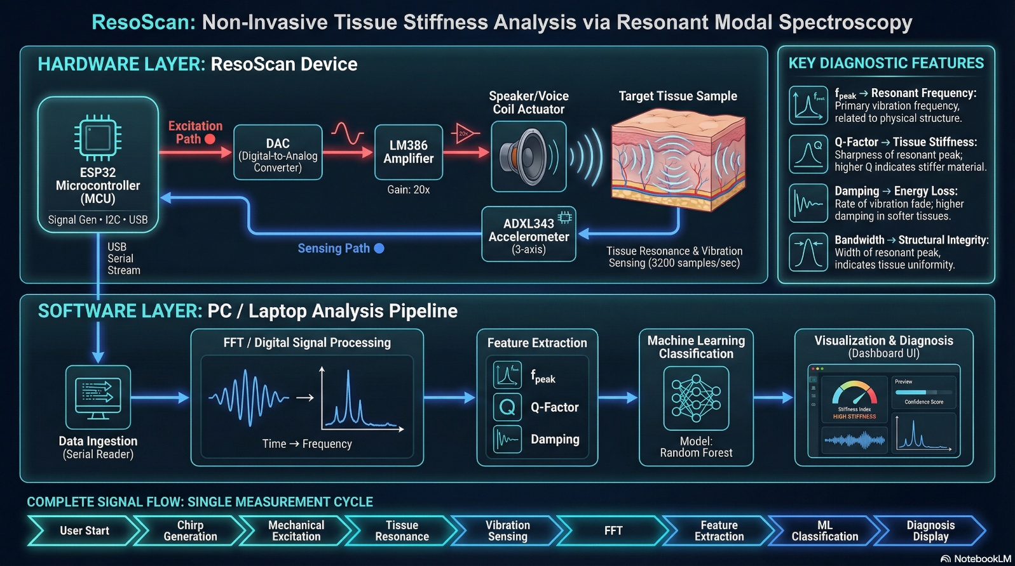
FIG 1. End-to-End Signal Flow & Analysis Pipeline for ResoScan

Clinical Applications
ResoScan targets three initial clinical domains with well-defined, measurable protocols:

Application 1: Fracture Healing Monitoring (Orthopedics)
- Configuration: Pitch-catch — excitation at medial malleolus (ankle), sensing at tibial tuberosity.
- Key Metric: Tibial Stiffness Index (TSI) = f²_injured / f²_healthy × 100%.
- Clinical Threshold: TSI > 80% indicates the bone is safe for weight-bearing.
- Clinical Value: Removes reliance on lagging X-ray evidence for return-to-load decisions.

Application 2: Pneumothorax Detection (Pulmonology)
- Configuration: Direct percussion on chest wall, intercostal space, mid-clavicular line.
- Key Metric: Power ratio in 200–400 Hz band (left side vs. right side comparison).
- Clinical Threshold: Ratio > 2.0 indicates hyper-resonance (air trapping = pneumothorax).
- Clinical Value: Enables point-of-care diagnosis by paramedics within minutes — no imaging required.

Application 3: Bladder Compliance (Urology)
- Configuration: Lamb wave propagation from suprapubic region (20–100 Hz) with lateral sensing.
- Key Metric: Wave velocity cₑ (m/s) measured 5–10 cm from excitation point.
- Clinical Threshold: cₑ > 4 m/s indicates elevated intravesical pressure.
- Clinical Value: Eliminates need for catheterization in routine bladder compliance monitoring.

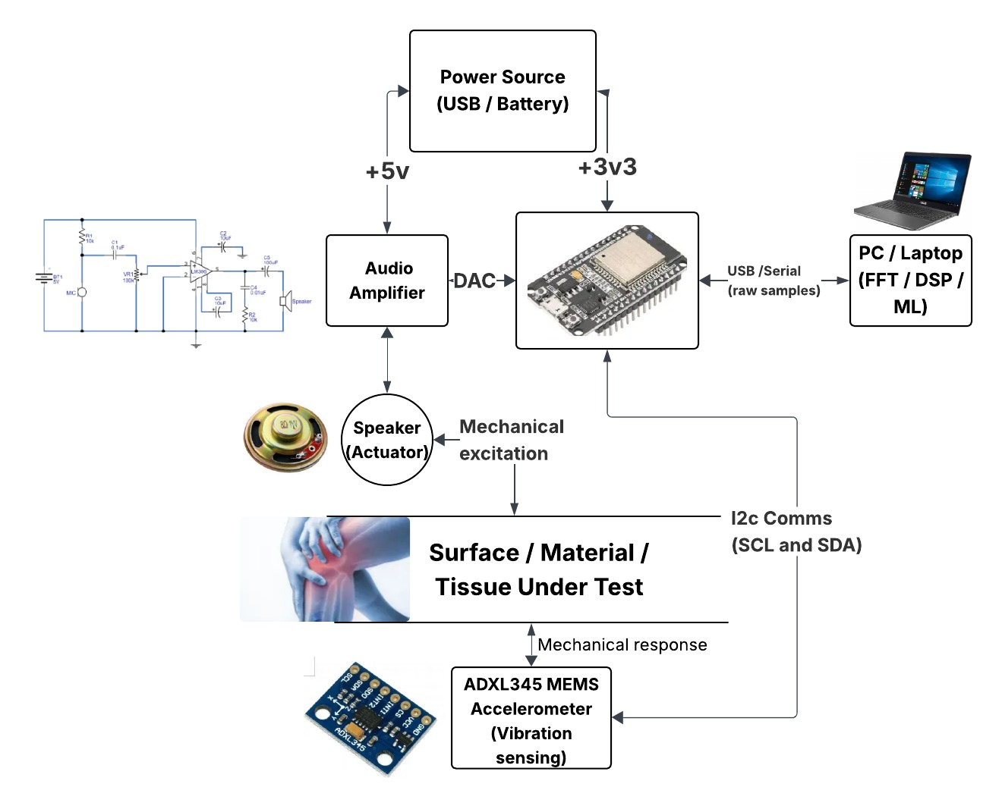
FIG 3. System Block Diagram for ResoScan

Hardware Architecture & Bill of Materials
The entire device is designed to be manufactured with a BOM under ₹8,000 INR using readily available components:

Component | Role | Est. Cost (INR)
ESP32 MCU | Signal generation (DAC) + data processing + USB communication | ₹415
MEMS Accelerometer (ADXL343) | Capture tissue vibrational response at 3200 Hz | ₹415–665
Voice Coil Actuator (VCA) | Deliver controlled mechanical impulses to tissue | ₹1,250–2,075
Amplifier | Drive the VCA with sufficient power | ₹165–415
Force Sensor | Standardize probe contact force for repeatability | ₹250–415
Battery & Charger | Portable power supply | ₹415
Enclosure | Handheld ergonomic housing | ₹830
Coupling Tip | Interface between device and body surface | ₹165
Miscellaneous | PCB, wiring, connectors | ₹830
TOTAL BOM | — | ₹5,000–6,500

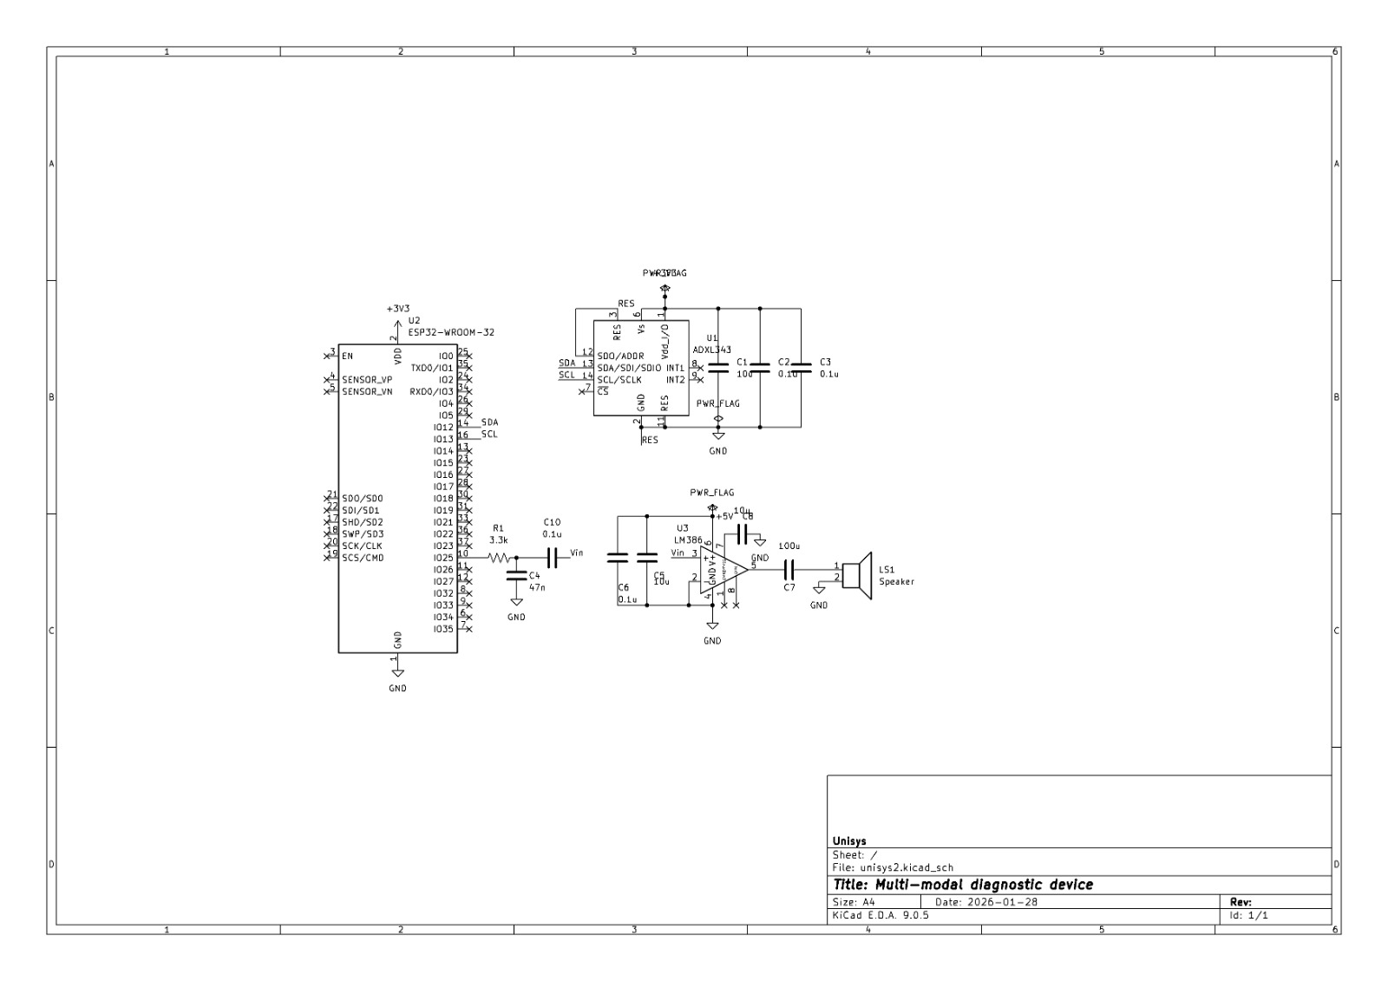
FIG 2. Hardware Schematic for Resonant Modal Spectroscopy Device

Software Stack
Layer | Technology / Tools
Embedded Firmware | Arduino / ESP-IDF on ESP32
Signal Processing | Python (NumPy, SciPy) — FFT, PSD, peak detection
Data Visualization | PyQtGraph — real-time spectrogram display
Machine Learning | Scikit-learn / TensorFlow — Random Forest, SVM classifiers
User Interface (Prototype) | PyQt5
User Interface (Future) | React-based web dashboard
Data Storage | SQLite (local) / Firebase (cloud)

Innovation & Novelty
What Makes ResoScan Different
Existing commercial devices like Osstell, MyotonPRO, and FibroScan are domain-specific and expensive (₹3-37 Lakhs).
ResoScan generalizes Resonant Modal Spectroscopy across multiple domains in one affordable handheld platform.
It transforms a subjective, skill-dependent clinical technique (percussion) into an objective, reproducible measurement.
At under ₹8,000, it fills the 'Missing Middle' between basic examination tools and expensive imaging systems.

Expected Outcomes & Deliverables
Deliverable | Success Criteria
Functional Prototype | Working handheld device with real-time FFT visualization on PC
Material Differentiation Proof | Measurable spectral differences between materials of varying stiffness
Biological Signal Acquisition | Successful resonance capture from human tissue (shin bone vs. calf muscle)
Stiffness Correlation | Established relationship: resonant frequency² ∝ stiffness / mass
ML Classification Accuracy | Greater than 80% accuracy on validation dataset
User Interface Dashboard | Real-time spectrogram + stiffness index + clinical indicators
Reproducible Protocol | Documented procedure with calibration routines for consistent measurements
Cost Validation | Confirmed BOM under ₹8,000 INR
Clinical Trial Foundation | Technical documentation suitable for future IRB-approved trials

Future Development Roadmap
- Clinical Validation: IRB-approved trials to build clinical evidence.
- Regulatory Pathway: Target FDA Class II / De Novo clearance.
- Miniaturization: Integrate all components into a single handheld unit.
- ML Expansion: Expand classifier models with large clinical datasets.
- Condition-Specific Algorithms: Develop targeted diagnostic modules per condition.
- Use Cases Enabled: Paramedic pneumothorax detection, sports medicine clearance, home bladder monitoring.

Vision Statement
"ResoScan envisions a future where every clinic, ambulance, and home has access to functional diagnostic technology.
By bridging the gap between the art of medicine and the science of measurement, ResoScan aims to democratize diagnostics and improve patient outcomes globally."

Key References
The project is grounded in published peer-reviewed research:
- Vibrational method for bone fracture healing assessment. PMC, 2021.
- Non-invasive bladder compliance assessment via ultrasound. PubMed, 2021.
- Tabla: Auscultatory percussion device for pneumonia detection. PMC, 2018.
- Lamb wave-based internal pressure measurement. PMC, 2022.
- FDA Clearance of OsteoProbe for bone material strength (K250216). BioSpace, 2025.
- MyotonPRO technology and FibroScan transient elastography methodology.

Keywords
Resonant Modal Spectroscopy • Non-Invasive Diagnostics • Tissue Stiffness • Mechanical Impedance Analysis • Fracture Healing Monitoring • Pneumothorax Detection • Bladder Compliance • Voice Coil Actuator • MEMS Accelerometer • Fast Fourier Transform • Point-of-Care Diagnostics • Machine Learning Classification • ESP32 • Low-Cost Medical Devices • Portable Healthcare Technology • Lamb Wave Analysis • Digital Percussion • Elastography

